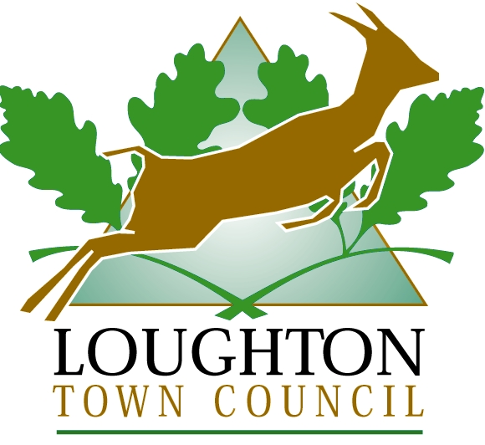

Join us for the

ANNUAL TOWN MEETING
at 8pm
on
WEDNESDAY 15 March 2023
(doors open at 7.30pm to view the displays)
in
The Murray Hall 106 Borders Lane,
Loughton, IG10 3SB

This is the ideal opportunity to
meet your local councillors,
ask questions and express your views

~~~~~~~~~~~~~~~~

Presentation of Awards to:
Citizen of the Year
Loughton 2023 Building Design Award
Local organisations receiving Grant Funding

~~~~~~~~~~~~~~~~

Loughton Town Council, 1 Buckingham Court, Rectory Lane, Loughton IG10 2QZ
contact@loughton-tc.gov.uk 020 8508 4200

