LOUGHTON BUILDING DESIGN AWARDS

2026

Loughton Town Council invites nominations for its Building Design Awards to celebrate great design. The awards aim to give public recognition to recent local building projects in
Loughton which make a positive contribution to the local environment.

We encourage local residents, groups and societies as well as architects and developers to send us your nominations. Tell us about schemes in Loughton, large or small, which you think are successful, noteworthy in terms of design or innovation and enhance the town.

Projects should have been completed within the last two years and can include:

New buildings – residential, community, educational, commercial: or

Alterations to an existing building – extensions, refurbishments, conversions or restorations.

The nominations for 2026 Awards are now open and will close on 30 January 2026.
Don’t forget everyone can nominate a great design in Loughton.

We would ask you to consider the following aspects when making a nomination:
Quality – is it of the highest quality in terms of its design, materials used or
construction?
Visual Amenity – how well do the alterations relate to the existing building and for a new building does it compliment the neighbourhood?
Innovation – is it an original solution to design or construction problems?
Sustainability – does the project promote environmental issues such as the use of
recycled materials, alternative energy sources, waste management and water saving?

2024 Awarded Certificates of Merit
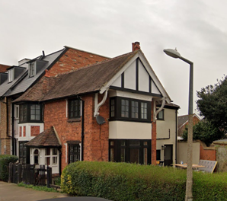
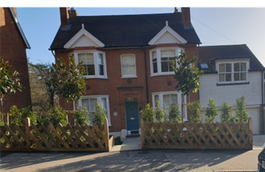

5 Staples Road 7 High Beech Road

Previous Award Winners

2023 Winner – 49 Church Lane

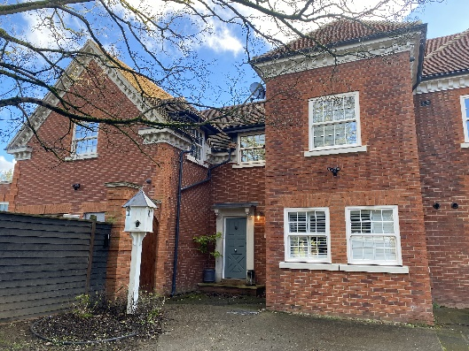

2022 Winner – 140 Forest Road

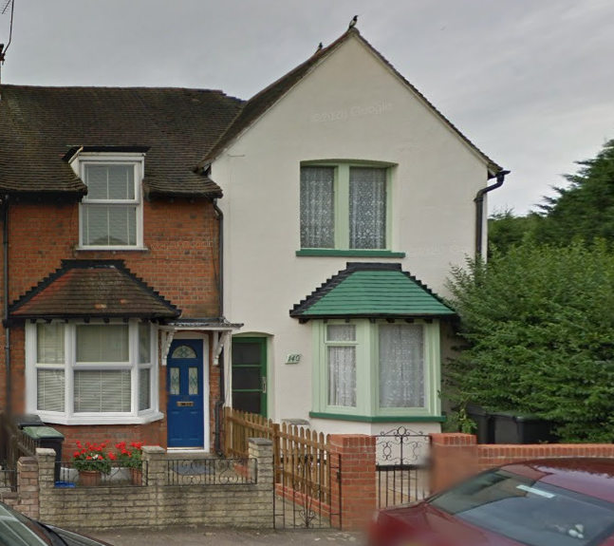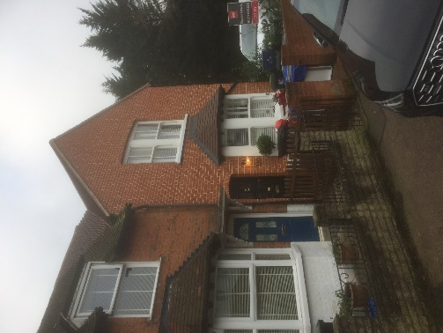
140 Forest Road After
140 Forest Road
Before

2021 Winners

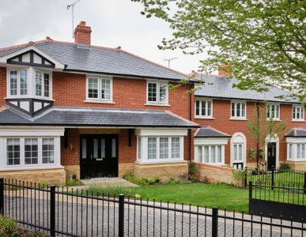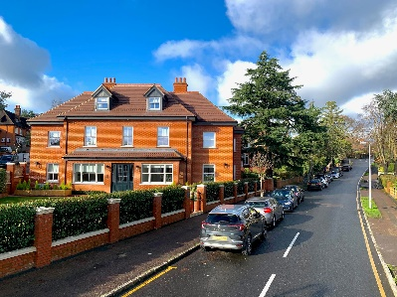

2 Connaught Avenue
Royal Oak Close

2020 Winner – 1 Hillcrest Road
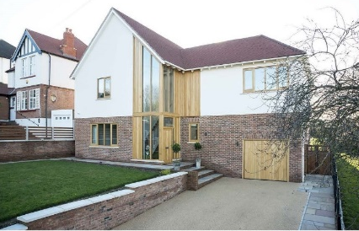

Winners of certificates of commendation in 2018

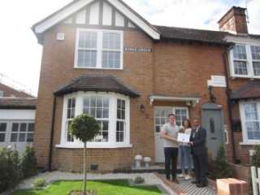
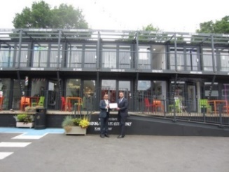

1 Kings Green
Crate Business Centre

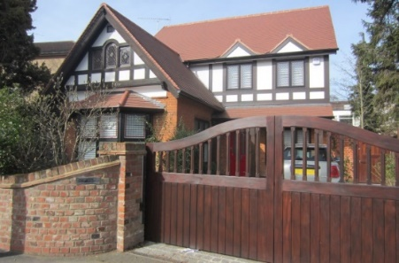
Winner 2017 – The Lodge,
90 High Road

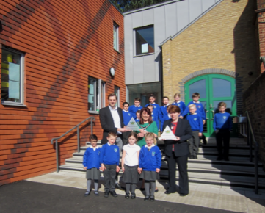

2016 – Staples Road Primary School

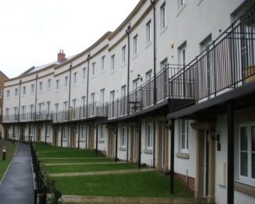
2013 – Borders Crescent

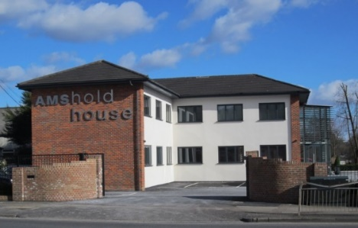

2013 – Amshold House
1 Goldings Hill

IN CONFIDENCE

LOUGHTON BUILDING DESIGN AWARDS
NOMINATION FORM

Please complete sections 1–5 and return the form to contact@loughton-tc.gov.uk
or by post to Loughton Town Council, 1 Buckingham Court, Rectory Lane, Loughton, IG10 2QZ,
together with a photograph of the property. The closing date for entries is 30 January.

1 | Address (of scheme)
2 | What is the scheme (please provide full details and continue on a separate sheet if necessary)
3 | Date of completion (of scheme)
4 | Reasons for your nomination
5 | Your details (in CAPITALS)

Name
Address

 | Tel (day)  Email | Date (of nomination)

Data Protection - Loughton Town Council is registered under the Data Protection Act as a Data Controller,
registration number PZ1870535, and will at all times use its best endeavours to comply with the terms of the
Act in all dealings with your personal data.

TERMS AND CONDITIONS

1. Works or improvements carried out by, or for a member of Loughton Town Council and its employees, or their relatives, are not eligible for this award.

2. Nominations are to be submitted on the form provided by 30 January.

3. A photograph should be included with the application.

4. You can nominate your own project but if nominating for a third party please do not inform the nominee you have put his/her property/project forward.

5. The building must be located within the town of Loughton.

6. The applications will be checked by Loughton Town Council officers to confirm compliance with current planning legislation and building regulations.

7. The judging panel will comprise the Town Mayor and Chairmen of the Planning & Licensing and
Environment & Heritage Committees, whose decision will be final.

8. There is no compulsion to award in the absence of valid nominations.

9. The award presentations will take place at the Council’s Annual Town Meeting on 18 March 2026.

FOR OFFICE USE ONLY:

Your details

Name
Address
Tel
Email

Owner details

Name
Address
Tel
Email

Planning Permission
(Ref no. if applicable)
Building Control
(Ref no. if applicable)

