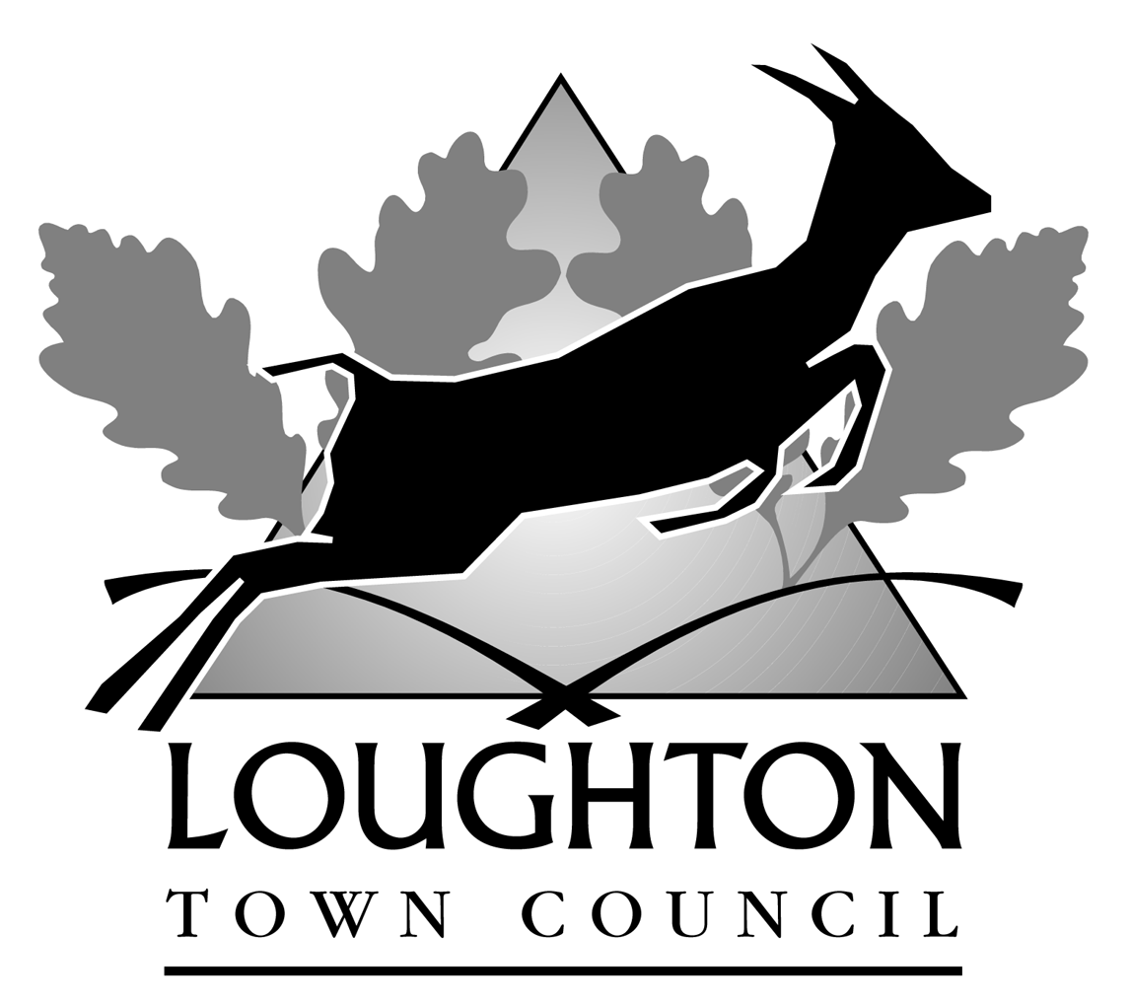

LOUGHTON CITIZENSHIP AWARDS

Citizenship is the engagement of the individual in the service of the community.

It may take the form of a single act of outstanding courage or bravery, or might encompass sustained effort on behalf of a voluntary organisation or organisations, continual good-neighbourliness, running a campaign to improve community facilities or cohesion, or to combat some defect or lack of provision, e.g. to resist something that might adversely affect the environment of the town.

Loughton Town Council will recognise each year significant contributions to citizenship in the following three categories:

(A) Acts of courage or bravery in the year in question that have resulted, for instance, in the prevention of a serious crime or the rescue of individuals from danger.
This is intended for people who are not employed by an emergency service.
The nominees may be either (a) an inhabitant or worker of Loughton, or (b) if they live elsewhere, must have exercised their courage in the town, e.g. by rescuing a Loughton citizen or stopping a crime in the town.

(B) Voluntary Service:
(i) For people aged 25 or over
(ii) For people under 25 years of age
Nominees should either work (on a paid or voluntary basis), be in education or live in Loughton. Without being too prescriptive, they should have a record of work for the community (not confined to a single year for example), for one or more voluntary or largely voluntary organisations, or for neighbours or other groups. The panel will assess the degree to which their voluntary activity has contributed to the well-being, culture, or charitable resources of Loughton.
The division is made at age 25 largely to reflect the longer time older people have had to assemble a ‘community curriculum vitae’, and be able to recognise young family people as well as students.
Service to national charities is valid only if there are identifiable Loughton benefits.

Please read the Terms and Conditions shown on page 4
before completing the form.

Data Protection - Loughton Town Council is registered under the Data Protection Act as a Data Controller, registration number PZ1870535, and will at all times use its best endeavours to comply with the terms of the Act in all dealings with your personal data.

IN CONFIDENCE

LOUGHTON CITIZENSHIP AWARDS

APPLICATION FORM

(Please complete the form clearly in black ink using capital letters and keep within the boxes. Continue on another sheet of paper if necessary)

Name of nominee
Address of nominee
Telephone number
Email address
Which category is nomination for - A or B?

Nomination for Category A awards (Acts of courage or bravery)
1 | Give a full account of the act of bravery or courage in respect of which the nomination is made. Continue on a separate sheet if you wish.
2 | Where did the act take place?
3 | If the nominee was not a resident of Loughton at the time, which Loughton resident did it benefit?

Nomination for Category B awards (Voluntary Service)
Nominee under 25 years of age |  |  | Nominee aged 25 or over
1 | Give an account of the voluntary activity the nominee has undertaken (including the period of activity), with a brief curriculum vitae.
2 | What, in your view, are the benefits for the well-being, cultural or charitable resources and community of Loughton that have accrued from her/his activities?

YOUR DETAILS
Name
Signature
Address
Telephone number
Email address
SUPPORTER/REFEREES
Name of supporter/referee 1
Address

Telephone number/Email address
Name of supporter/referee 2
Address
Telephone number/Email

TERMS AND CONDITIONS

1 People may be nominated by any inhabitant of Loughton or by a Loughton employer, educational institution, group or society. Nominees for preference should not have been given awards by other bodies for the same service.
2 Please do not inform the nominee you have put his/her name forward.
3 Applications are to be submitted on the form provided by 31 January.
4 Two supporters and/or referees details are required for each nomination.
5 Loughton Town Council officers and councillors (of any authority) are disqualified from being nominated in Categories B (i) and (ii).
6 Service in political organisations is excluded from all categories. Service to religious bodies is applicable only if it involves a substantial contribution to the wider community.
7 The judging panel will comprise the Town Clerk, Town Mayor, Deputy Town Mayor and Chairman of the Resources and General Services Committee, whose decision will be final.
8 One award and one runner up will be made in each category. However, there is no compulsion to award in the absence of valid nominations.
9 For each category, the winner’s prize will be an illuminated scroll, plus a cheque for £250 made payable to whichever local charity the winner nominates or, if she/he does not want to nominate a charity, the Council reserves the right to use the money in its Financial Assistance Scheme.

Please return completed nomination forms by 31st January to:

Loughton Citizenship Awards
Loughton Town Council
Loughton Library and Town Hall
Traps Hill
Loughton IG10 !HD

Please mark your envelopes “PRIVATE & CONFIDENTIAL”

