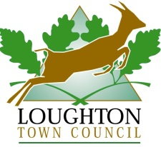
Loughton Horticultural Show Entry Form
Saturday 7 September 2024

Please complete and return this to:
Loughton Town Council, 1 Buckingham Court,
Rectory Lane, Loughton IG10 2QZ
Not later than 12 noon on Friday 6 September 2024
Please include the entrance fee 50p for each class

DATA PROTECTION POLICY
Loughton Town Council only undertakes the processing of personal data necessary to perform the contract for services with you. Our Data Protection Policy Statement forms part of the agreement and includes the binding obligations on us covering the duration, nature and purpose of the processing; copies are available on request from the Town Council or available on our website: https://tinyurl.com/y8sxohqs

Name | (Mr/Mrs/Ms/Miss/Master)
Address | Post Code

Pre-school □
Children (up to 10yrs) □ 
Children (11years – 16yrs) □ 

E-mail address | Telephone number

Classes Entering

1.

2.

3.

4.

5.

6.

7.

8.

Please photocopy this form for additional entries www.loughton-tc.gov.uk

Total number of classes @ 50p ………. I enclose £ ………………. p entry fee

By submitting this form you agree to abide by the rules and regulations set out by Loughton Town Council

Signed ……………………………………… Date ………………………………..

