PRESS RELEASE

Loughton’s latest Blue Heritage Plaque

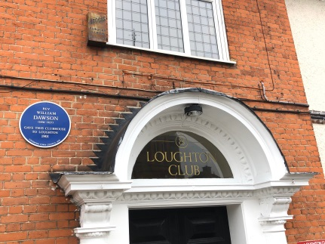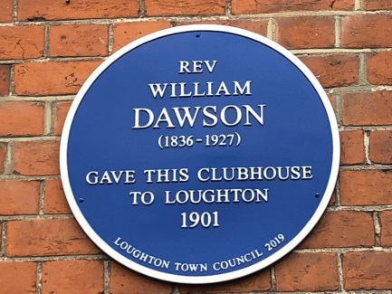

Deputy Town Mayor, Cllr Tessa Cochrane hosted the dedication ceremony of the latest blue heritage plaque, the 43rd in this scheme, on Tuesday 21 January 2020 at The Loughton Club. Rather aptly, it followed a talk given by Chris Pond on ‘Old Loughton’ to the New Vistas Group which regularly meets at this venue. The plaque was installed to commemorate the Reverend William Dawson, who gave The Loughton Club to the people of Loughton in 1901.

Cllr Chris Pond, Chairman of the Environment and Heritage Committee, informed those present of Reverend Dawson’s life and connection to the town.

William Dawson was the son of the vicar of East Harling in Norfolk. He was sent to Harrow School and then to Exeter College, Oxford. Oxford in the 1850s was not noted for academic excellence, most didn’t take a degree, but William got honours 1st class in Law. He might have ended up a Judge, but his vocation was with the Church of England, he was ordained, and in 1870 became Rector of St John Church, Clerkenwell.

This was a poor parish, of which the church was situated near to Farringdon Station. One of the troubles, William wrote, was that “few of those that work here live here, and few of those who dwell here work here”. In his 23 years at Clerkenwell he caused the clear up of St John’s burial ground and conversion to a public park (which is still there today), and wrote the history of the parish.

He came to Loughton in about 1892 and built a house for himself, Susancroft, in Upper Park, on what had once been the yard of the Crown Inn, before it moved. He assisted, unpaid, at St Mary’s Church and continued working as Warden of the Finsbury & East London Polytechnic.

Dawson was an anti-drink campaigner. He said that the men and youths of Loughton in their leisure time had nothing to do bar go to the pub. So he gave to Loughton a building where men and boys could gather, in a dry building, at minimal cost, for games and recreation. He was always ready to put his money where his mouth was. In 1901, he arranged for the present clubhouse to be built, and supported it for the rest of his life.

William Dawson died at Susancroft on 1 November 1927. He is commemorated by the large oil painting in the stairwell of the club. He is one of Loughton’s great benefactors and it’s entirely appropriate that this plaque to his memory has been provided by Loughton Town Council, to remind passers-by of this man and his gifts.

End

Note to editor:
This is part of the town council’s ongoing scheme to place blue plaques on a number of properties within Loughton to commemorate either famous former residents or the building itself. This is as a result of the Council’s desire to open up aspects of Loughton’s heritage and make it better known and valued. More details of the plaques may be found at http://www.loughton-tc.gov.uk/2bhpl.htm

For more information contact:
Mark Squire or Debra Paris
Loughton Town Council | 020 8508 4200 | contact@loughton-tc.gov.uk
Date: 29 January 2020

