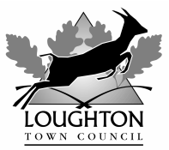

PRESS RELEASE

BLUE HERITAGE PLAQUE

Barbara Harmer – First Female Supersonic Pilot
91 Staples Road, Loughton IG10 1HR

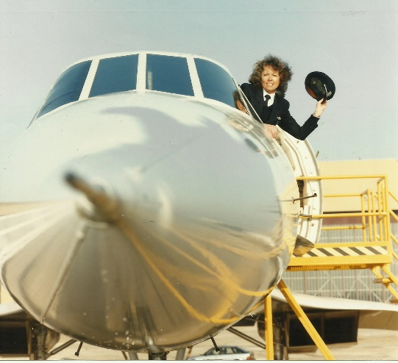
© BA Press Office

Since 1999, Loughton Town Council has installed a series of blue heritage plaques around the town to commemorate eminent people, historic events and/or significant buildings.

The latest plaque to be installed is in honour of Barbara Harmer, the first female supersonic pilot.

The plaque is installed at 91 Staples Road, where Barbara Harmer was born in 1953. Her family moved to West Sussex when she was five years old. At 15 years of age Barbara left school and became a hairdresser. Five years later, in search of a challenge, she achieved a trainee position as an air traffic controller at Gatwick Airport. Meanwhile, with the initial intention of gaining a law degree, she began studying for A-levels, by herself with no tuition.

However, being surrounded by aircraft her intentions changed and she wanted to take to the air herself. Along with her £5,000 savings and a £10,000 loan she paid for her own flying lessons and earned herself a pilot’s licence, taking control of an aircraft for the first time in December 1975.

Following a new job as a flying instructor at Goodwood Airport, Barbara spent the next two years studying by correspondence course for her commercial pilot’s licence, passing in 1982. Achieving her ambition of becoming a civil aviation pilot proved more difficult than envisioned. After submitting more than 100 applications, she was finally offered a post with Genair, a small commuter airline.

In 1984, she moved onto British Caledonian, and had her first experience of jet airliners. Four years later Caledonian merged with British Airways and in 1992 Barbara (one of just 40 women, among 3,000 pilots) was selected for an intensive six-month conversion course for Concorde, costing £100,000, fortunately this time paid by her employer! Barbara succeeded in her training aided by the invaluable notes of her colleague and friend, Capt Phil Benson, who had undergone training for Concorde a few years earlier when the training was given by the engineers who had designed the aircraft. Apparently, flying Concorde was 2-3 times more difficult than usual aircraft.

On 25 March 1993, Barbara made history flying as first officer on a BA Concorde from London’s Heathrow to New York’s JFK airport. In 2001, an Air France pilot, Béatrice Vialle, became the second female to pilot Concorde before the service was finally withdrawn in 2003. Only one other woman flew the aircraft, during its development phase, French test pilot, Jacqueline Auriol. After Concorde, Barbara retrained to fly Boeing 777s and finally took redundancy from BA in 2009.

Barbara’s passions didn’t stop at flying, she was also a qualified offshore yacht master with plans to take part in a transatlantic event in 2013 with her partner Andy Hewitt. Sadly, in 2009 she was diagnosed with ovarian cancer and died at St Wilfrid’s Hospice in Chichester on 20 February 2011, aged 57, having married her partner shortly before her death.

Not long after she began piloting Concorde, during an interview Barbara said “…there’s nothing else like it. Even pilots stop and stare, it has an aura about it.” Hopefully, people will stop and stare at this plaque in recognition of a remarkably determined and successful woman.

We are grateful to the property owners Deborah and Paul Davis for supporting this scheme. In fact, this is actually the second plaque adorning their home, which is also on the site of the former Oriolet Fruitarian Hospital (1895-1903).

End

Note to Editor:
Photo attached:
- Blue heritage plaque and inscription
The plaque inscription reads:
Barbara Harmer (1953 – 2011) First Woman Supersonic Airline Pilot, born here
- Photograph of Barbara Harmer from the cockpit window of Concorde – copyright BA Press Office.

This latest plaque brings the total installed by the town council to 43.

More information can be found on the town council’s website at

http://www.loughton-tc.gov.uk/2bhpl.htm

Contact:
Mark Squire or Debra Paris
020 8508 4200
7 September 2020

