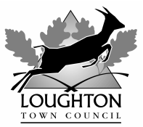

PRESS RELEASE

BLUE HERITAGE PLAQUE

Rudyard Kipling and Stanley Baldwin
Goldings Manor Cottage, 3 Stanmore Way, Loughton IG10 2SA

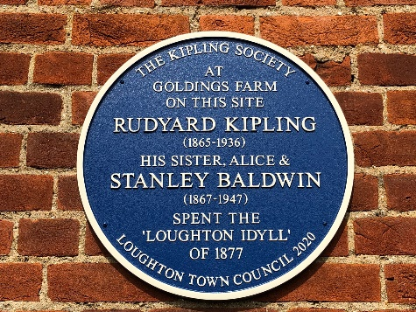

As part of its blue heritage plaque scheme, which aims to raise awareness of Loughton’s rich history, Loughton Town Council installed its 44th blue heritage plaque this summer to commemorate the ‘summer idyll’ spent by Rudyard Kipling, his sister Alice (Trix) and cousin Stanley Baldwin at Goldings Hill Farm, in 1877.

The plaque has been installed on the site at Goldings Manor Cottage, 3 Stanmore Way.
Our gratitude is extended to the property owners Mr & Mrs Bassi for supporting this scheme.

A new book detailing this event, researched by Janice Lingley, a member of the Kipling Society who made a contribution towards the cost of this plaque, is available through the library or bookshop (price £6.50).

This was one of two plaques commissioned and was being cast when the Coronavirus lockdown was instigated, It is hoped that a dedication ceremony can be held later in the autumn, if Covid restrictions are eased.

End

Note to Editor:
Photo attached:
- Blue heritage plaque and inscription
The plaque inscription reads:
At Goldings Farm on this site Rudyard Kipling (1865-1936) his sister Alice & Stanley Baldwin (1867-1947) spent the ‘Loughton Idyll’ of 1877

This latest plaque brings the total installed by the town council to 44.

More information can be found on the town council’s website at

http://www.loughton-tc.gov.uk/2bhpl.htm

Contact:
Mark Squire or Debra Paris
020 8508 4200
14 September 2020

