PRESS RELEASE

Countdown to Christmas 2019

Local residents are invited to come together on Debden Broadway on Friday 6 December 2019 3.30pm to 5.30pm for the annual Countdown to Christmas event.

Santa will arrive with the Town Mayor, Councillor Stella Murphy, on a horse & carriage. There will be funfair rides, live entertainment, festive crafts, food & games stalls, horse and carriage rides along the Broadway and a pony from Chigwell Riding Trust. All funds raised at the event will go to the Chigwell Riding Trust.

The event is sponsored by local business’ with special thanks to the Debden Traders, Restore Community Church, Epping Forest Community Church, Red Balloon Foundation, Galliard Homes, Higgins and Alere Toxicology.

There will be free parking in the Vere Road car park during the event.

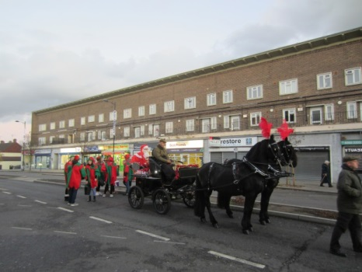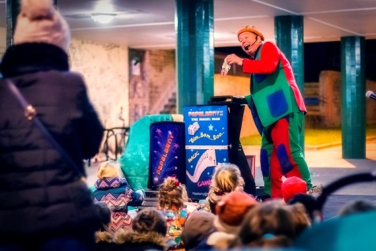

Note to editor:
For more information contact
Mark Squire (Town Clerk)
Tel: 020 8508 4200

Date: 26 November 2019

