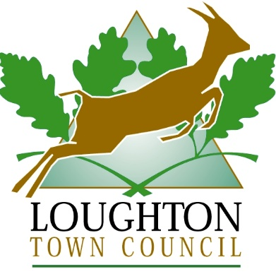

Christmas and New Year
Opening Hours 2022/23

Friday 23 December | Closed 12 noon
Monday 26 December | Closed
Tuesday 27 December | Closed
Wednesday 28 December | 10am – 3pm
Thursday 29 December | 10am – 3pm
Friday 30 December | 10am – 12.45pm
Monday 2 January | Closed

If you wish to leave a message on our answerphone we will get back to you on our return
Tel: 0208 508 4200

