PLANNING AND
LICENSING
COMMITTEE

Members of the Planning and Licensing Committee

are summoned to attend a Meeting at 7.45pm on

Monday 2 March 2020

at Loughton Library, Traps Hill, Loughton, IG10 1HD
to transact the business shown in the agenda.

Mark Squire
Town Clerk
25 February 2020

Councillor J Angold-Stephens (Chairman)
Councillor K Latchford (Vice Chairman)

Councillors
P Abraham | T Cochrane | C Davies
T Downing | S Murphy

Note to Councillors:
If you are unable to attend the meeting,
please phone your apologies to the office on 020 8508 4200.
Members of the public are welcome to appear in person at the meeting to make the case for or against a particular application. However, they must have pre-registered to speak by contacting the Council on 020 8508 4200 no later than 3pm on the day of the meeting. Speakers whether for or against will each have a maximum of 3 minutes to address the Committee. Under the Council’s rules only those registered may speak during the meeting. (see also Appendix B of the Standing Orders for more information)

AGENDA

1 Apologies
To RECEIVE any apologies for absence.

2 Declarations of interest
For Councillors to DECLARE any pecuniary or non-pecuniary interest in any item on the Agenda.

3 Confirmation of Minutes
To CONFIRM the minutes of the meeting of the Planning and Licensing Committee held on 17 February 2020.

4 Matters for Report
To REPORT any further significant information on matters which have been previously discussed, in addition to those which may already be included on the Agenda.

4.1 Amended Plans

4.1.1 EPF/2418/19 – 33 Valley Hill, Loughton, Essex, IG10 3AE. Proposal: Proposed first floor extension/loft conversion. Double width garage to replace the existing single garage. Increase the width of existing dropped kerb to facilitate access to the new garage. ** AMENDED PLANS ** – Min no PL824.1
To CONSIDER the amended plans received from Epping Forest District Council.
If you are viewing this report in an electronic format, click on the link below to view related documents including plans
http://planpub.eppingforestdc.gov.uk/NIM.websearch/ExternalEntryPoint.aspx?SEARCH_TYPE=1&DOC_CLASS_CODE=PL&FOLDER1_REF=629133

4.1.2 EPF/1113/19 – 305 - 307 High Road, Loughton, IG10 1AL.
Proposal: Change of use from Class A1 use (shops) to Class A3 use (Including Extraction and Ventilation Details). ** AMENDED PLANS ** – Min no PL730.1
To CONSIDER the amended plans received from Epping Forest District Council.
If you are viewing this report in an electronic format, click on the link below to view related documents including plans
http://planpub.eppingforestdc.gov.uk/NIM.websearch/ExternalEntryPoint.aspx?SEARCH_TYPE=1&DOC_CLASS_CODE=PL&FOLDER1_REF=623517

4.2 Notice of Appeal

4.2.1 EPF/1767/19 – 48 Harwater Drive, Loughton, IG10 1HS.
Proposal: Two storey side, single storey rear and front extensions. (Appeal ref no: APP/J1535/D/19/324299) – Min no PL742.1
For information only: An appeal has been made to the Secretary of State in respect of the above site. The appeal is Against a Refusal, following the decision of Epping Forest District Council. The appeal is to be determined on the basis of written representations.
The Committee is advised that as the appeal is proceeding under the Householder Appeals Service there is no opportunity to submit further comments. The District Council will forward on all representations it has received to the Planning Inspectorate and the appellant unless withdrawn. The Planning Inspectorate aims to deal with appeals that follow the above procedure within 8 weeks of the appeal start date of 18 February 2020.

5 Planning Applications
5.1 To CONSIDER the planning applications received for the weeks
14 February and 21 February 2020.
Members are reminded that when raising an objection to an application, they should also consider whether to confirm in writing their intention to attend and speak at the Area Planning Sub-Committee South where the proposal was to be considered.
Application No: EPF/0029/20
Officer: Sukhdeep Jhooti
Applicant Name: Mr John Mitchell
Planning File No: 016231
Location: 18 Roundmead Close, Loughton, IG10 1QD
Proposal: Proposed planning approval for all three (3) air source pumps to remain on property.
If you are viewing this report in an electronic format, click on the link below to view related documents including plans
http://planpub.eppingforestdc.gov.uk/NIM.websearch/ExternalEntryPoint.aspx?SEARCH_TYPE=1&DOC_CLASS_CODE=PL&FOLDER1_REF=632014

Application No: EPF/0043/20
Officer: Natalie Price
Applicant Name: Ms Gail Thibert
Planning File No: 018496
Location: 12 Grosvenor Drive, Loughton, IG10 2LH
Proposal: Retrospective application for outbuilding.
If you are viewing this report in an electronic format, click on the link below to view related documents including plans
http://planpub.eppingforestdc.gov.uk/NIM.websearch/ExternalEntryPoint.aspx?SEARCH_TYPE=1&DOC_CLASS_CODE=PL&FOLDER1_REF=632113

Application No: EPF/0228/20
Officer: Muhammad Rahman
Applicant Name: Miri Shtini
Planning File No: 030527
Location: 86 Newmans Lane, Loughton, IG10 1TN
Proposal: Proposed two storey side extension, single storey rear extension, 2 no. rooflights and front porch roof modification.
If you are viewing this report in an electronic format, click on the link below to view related documents including plans
http://planpub.eppingforestdc.gov.uk/NIM.websearch/ExternalEntryPoint.aspx?SEARCH_TYPE=1&DOC_CLASS_CODE=PL&FOLDER1_REF=633074

Application No: EPF/0277/20
Officer: Muhammad Rahman
Applicant Name: Mr P Giordano
Planning File No: 003011
Location: 39 Albion Hill, Loughton, IG10 4RD
Proposal: Proposed rear single storey extension; amendment to part of roof to add x3 no. new dormers with internal alterations. (Revised application to EPF/1925/19)
If you are viewing this report in an electronic format, click on the link below to view related documents including plans
http://planpub.eppingforestdc.gov.uk/NIM.websearch/ExternalEntryPoint.aspx?SEARCH_TYPE=1&DOC_CLASS_CODE=PL&FOLDER1_REF=633317

Application No: EPF/0290/20
Officer: Natalie Price
Applicant Name: Mr Mark Redelinghuys
Planning File No: 030209
Location: 78 Avondale Drive, Loughton, IG10 3DQ
Proposal: Erection of a single storey rear extension including a raised patio. (Amended application to EPF/0748/19).
If you are viewing this report in an electronic format, click on the link below to view related documents including plans
http://planpub.eppingforestdc.gov.uk/NIM.websearch/ExternalEntryPoint.aspx?SEARCH_TYPE=1&DOC_CLASS_CODE=PL&FOLDER1_REF=633356

Application No: EPF/0297/20
Officer: Natalie Price
Applicant Name: Mr Stephen Shakeshaft
Planning File No: 015624
Location: 48 Lower Park Road, Loughton, IG10 4NA
Proposal: Proposed demolition and replacement of existing single storey rear extension. Loft extension including raising of the roof level & replacement of the existing single storey front bay with a two storey bay.
If you are viewing this report in an electronic format, click on the link below to view related documents including plans
http://planpub.eppingforestdc.gov.uk/NIM.websearch/ExternalEntryPoint.aspx?SEARCH_TYPE=1&DOC_CLASS_CODE=PL&FOLDER1_REF=633396

Application No: EPF/0304/20
Officer: Muhammad Rahman
Applicant Name: Mr I Umarji
Planning File No: 010806/ 011304
Location: 143-149 High Road and 2 Old Station Road, Loughton, IG10 4LY
Proposal: New entrance door in lieu of window on elevation facing High Road.
If you are viewing this report in an electronic format, click on the link below to view related documents including plans
http://planpub.eppingforestdc.gov.uk/NIM.websearch/ExternalEntryPoint.aspx?SEARCH_TYPE=1&DOC_CLASS_CODE=PL&FOLDER1_REF=633435

Application No: EPF/0320/20
Officer: Muhammad Rahman
Applicant Name: Mrs Jane Moir
Planning File No: 013777
Location: 20 Ollards Grove, Loughton, IG10 4DW
Proposal: Proposed loft conversion and extension with first floor alterations to form 5 bedroom dwelling.
If you are viewing this report in an electronic format, click on the link below to view related documents including plans
http://planpub.eppingforestdc.gov.uk/NIM.websearch/ExternalEntryPoint.aspx?SEARCH_TYPE=1&DOC_CLASS_CODE=PL&FOLDER1_REF=633477

Application No: EPF/0321/20
Officer: Robin Hellier
Applicant Name: Mr Houston
Planning File No: 001347
Location: 1 Salcombe Park, High Road, Loughton, IG10 4QT
Proposal: TPO/EPF/09/90 (Ref: T5)
T1 Oak - Reduce spread by up to 3m, height by up to 2m and reshape, as specified.
If you are viewing this report in an electronic format, click on the link below to view related documents including plans
http://planpub.eppingforestdc.gov.uk/NIM.websearch/ExternalEntryPoint.aspx?SEARCH_TYPE=1&DOC_CLASS_CODE=PL&FOLDER1_REF=633478

Application No: EPF/0327/20
Officer: Brendan Meade
Applicant Name: Mrs Victoria Coleman
Planning File No: 021572
Location: High Silver House, 37 Upper Park, Loughton, IG10 4EQ
Proposal: Proposed 2nd floor front dormer with flat roof.
If you are viewing this report in an electronic format, click on the link below to view related documents including plans
http://planpub.eppingforestdc.gov.uk/NIM.websearch/ExternalEntryPoint.aspx?SEARCH_TYPE=1&DOC_CLASS_CODE=PL&FOLDER1_REF=633494

Application No: EPF/0364/20
Officer: Robin Hellier
Applicant Name: Mrs Angela Harding
Planning File No: 012985
Location: 43 York Hill, Loughton, IG10 1HZ
Proposal: TPO/EPF/03/87
T9: Lime - Crown reduce to previous points, as specified.
Remove epicormic growth.
If you are viewing this report in an electronic format, click on the link below to view related documents including plans
http://planpub.eppingforestdc.gov.uk/NIM.websearch/ExternalEntryPoint.aspx?SEARCH_TYPE=1&DOC_CLASS_CODE=PL&FOLDER1_REF=633655

5.2 Determinations and Works to Trees in Conservation Areas. To NOTE the following TPX applications – provided for information only: (Members are reminded that comments are not normally accepted by Epping Forest District Council on these types of applications unless there are strong concerns.)
Application No: EPF/0366/20
Officer: Julie Cottrell
Applicant Name: Mr Keith Bacon
Planning File No: 023484
Location: Noakes Cottage, Steeds Way, Loughton, IG10 1HX
Proposal: York Hill Conservation Area
T1: Maple - Open out & thin crown. Reduce lateral branches.
T2: Holly - Reduce height by 0.5m & crown lift over pavement.
If you are viewing this report in an electronic format, click on the link below to view related documents including plans
http://planpub.eppingforestdc.gov.uk/NIM.websearch/ExternalEntryPoint.aspx?SEARCH_TYPE=1&DOC_CLASS_CODE=PL&FOLDER1_REF=633693

Application No: EPF/0374/20
Officer: Robin Hellier
Applicant Name: Mrs Angela Harding
Planning File No: 012895
Location: 43 York Hill, Loughton, IG10 1HZ
Proposal: York Hill Conservation Area
T1: Bay - Reduce height by up to 2m.
If you are viewing this report in an electronic format, click on the link below to view related documents including plans
http://planpub.eppingforestdc.gov.uk/NIM.websearch/ExternalEntryPoint.aspx?SEARCH_TYPE=1&DOC_CLASS_CODE=PL&FOLDER1_REF=633733

5.3 Deemed Permission – provided for information only: (Members are reminded that comments are not normally accepted on these applications).
There are no applications listed under Deemed Permission.
Application No: EPF/0333/20
Officer: Brendan Meade
Applicant Name: Mr Andrew Wintle
Planning File No: 024729
Location: 14 Oakwood Hill, Loughton, IG10 3EW
Proposal: Application for a Lawful Development Certificate for a proposed hip to gable loft conversion with rear dormer, Juliet balcony & x1 no. rooflight to the front elevation.
If you are viewing this report in an electronic format, click on the link below to view related documents including plans
http://planpub.eppingforestdc.gov.uk/NIM.websearch/ExternalEntryPoint.aspx?SEARCH_TYPE=1&DOC_CLASS_CODE=PL&FOLDER1_REF=633516

5.4 Others – provided for information only: (Members are reminded that comments are not normally accepted on these applications).
Application No: EPF/0275/20
Officer: James Ruffini Davis
Applicant Name: Mr Tom Claridge
Planning File No: 012453
Location: Royal Oak House, Forest Road, Loughton, IG10 1EG
Proposal: Application for Approval of Details Reserved by Condition 6"verification report" for EPF/2706/17. (Partial demolition of the former Royal Oak public house & change of use to provide 4 flats, demolition of 171 Smarts Lane & redevelopment for 6 dwellings, & associated parking &landscaping (10 dwellings in total).
If you are viewing this report in an electronic format, click on the link below to view related documents including plans
http://planpub.eppingforestdc.gov.uk/NIM.websearch/ExternalEntryPoint.aspx?SEARCH_TYPE=1&DOC_CLASS_CODE=PL&FOLDER1_REF=633315

Application No: EPF/0301/20
Officer: Graham Courtney
Applicant Name: Mr Steven Price
Planning File No: 012105
Location: 61 The Drive, Loughton, IG10 1HG
Proposal: Application for Prior Approval for a Larger Home Extension measuring 5.15 metres, height to eaves of 3.00 metres & a maximum height of 3.50 metres.
If you are viewing this report in an electronic format, click on the link below to view related documents including plans
http://planpub.eppingforestdc.gov.uk/NIM.websearch/ExternalEntryPoint.aspx?SEARCH_TYPE=1&DOC_CLASS_CODE=PL&FOLDER1_REF=633415

Application No: EPF/0342/20
Officer: Sophie Ward Bennett
Applicant Name: Martin Love
Planning File No: 021991
Location: 30 The Crescent, Loughton, IG10 4PY
Proposal: Application for Approval of Details Reserved by Conditions 2,3,4 &5 for EPF/2691/18. Condition 2"wheel washing/other cleaning facilities", 3"All construction/demolition works carried out within specified times", 4"Construction Method Statement" 5"soft landscaping & a statement of the methods". (First floor front, side & rear extensions.)
If you are viewing this report in an electronic format, click on the link below to view related documents including plans
http://planpub.eppingforestdc.gov.uk/NIM.websearch/ExternalEntryPoint.aspx?SEARCH_TYPE=1&DOC_CLASS_CODE=PL&FOLDER1_REF=633594

6 Decisions

6.1 Decisions by Epping Forest District Council
See Decisions for January 2020 (pages 7 – 12).

7 Local Government (Miscellaneous Provisions) Act 1982 Street Trading Licence

7.1 Street Trading Consent (Renewal) – Debden Broadway Market – Mr Peter Sparks of Debden Traders Association
The Committee is ASKED if it wishes to comment on the above application for renewal of street trading consent. Epping Forest District Council requires all representations by 10 March 2020.
* See notice on pages 13 – 14.

8 Licensing Applications
To CONSIDER any licensing applications which have come to the officers’ attention since the last meeting of the Committee. Members are reminded that reference must be made to at least one of the four licensing objectives to validate any objections, as detailed below:
- The prevention of crime and disorder
- Public safety
- The prevention of public nuisance
- The protection of children from harm

9 Enforcement and Compliance
9.1.1 To ADVISE the Committee of any updates to the reports previously received.
Enforcement Lists by Epping Forest District Council for the period 1 August 2019 – 24 January 2020 (cases opened and closed – not for public distribution).
* See attached Confidential Appendix 1 (pages 15 - 21).
Provided for information only

Mark Squire
TOWN CLERK
25 February 2020

Agenda item 6

Decisions
Loughton
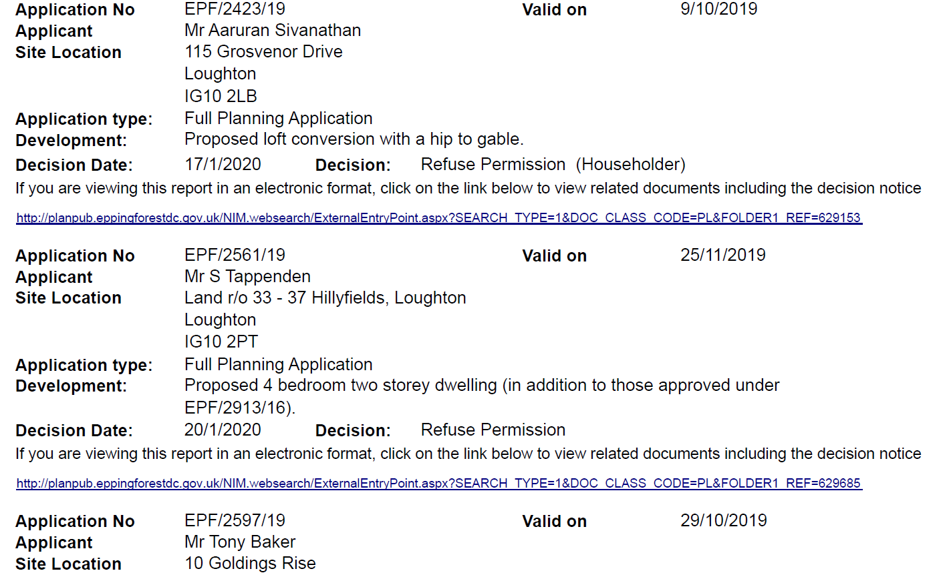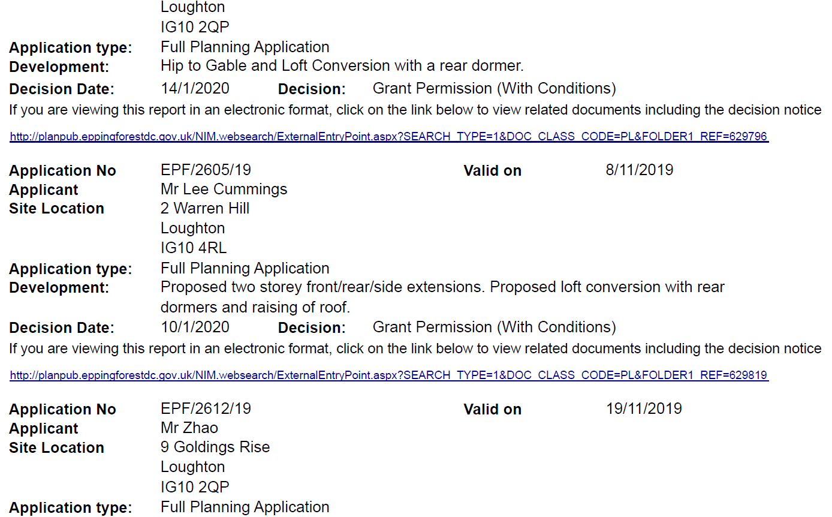

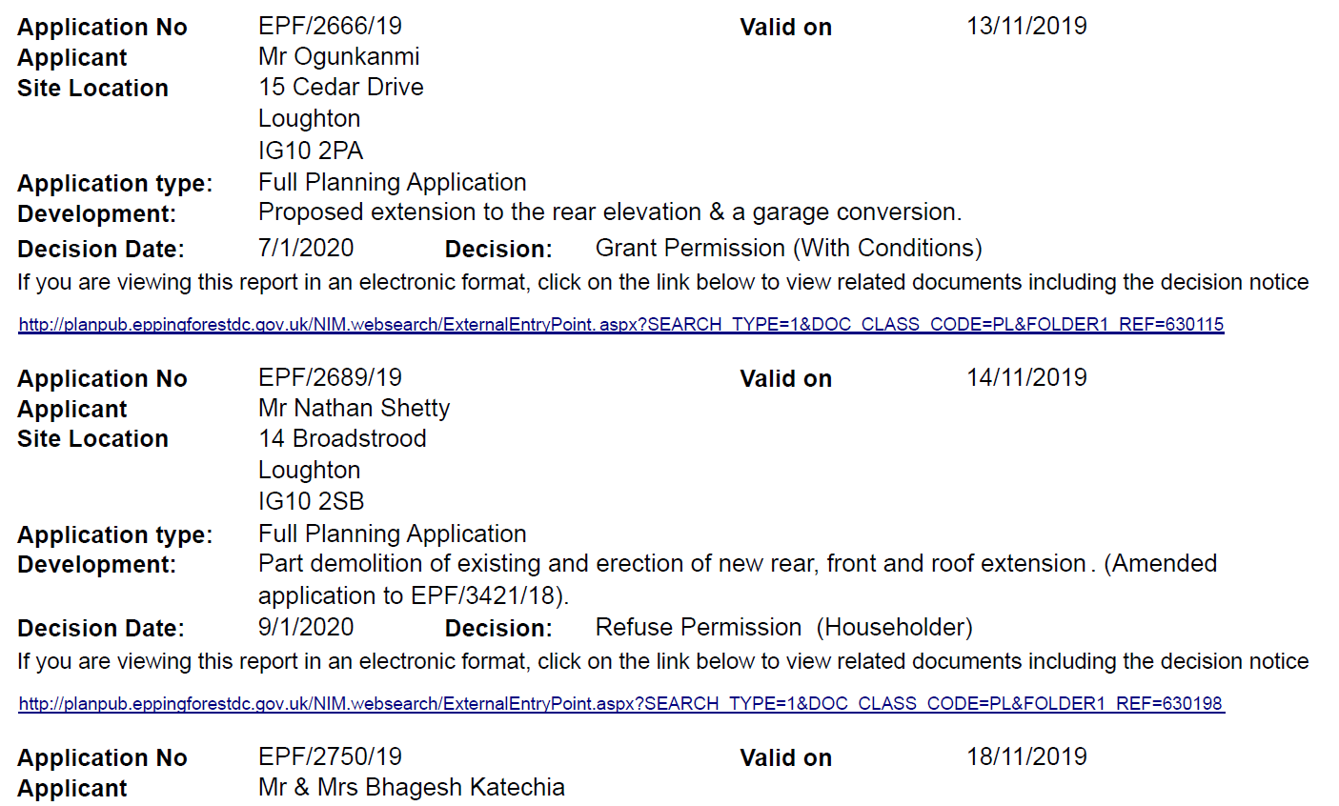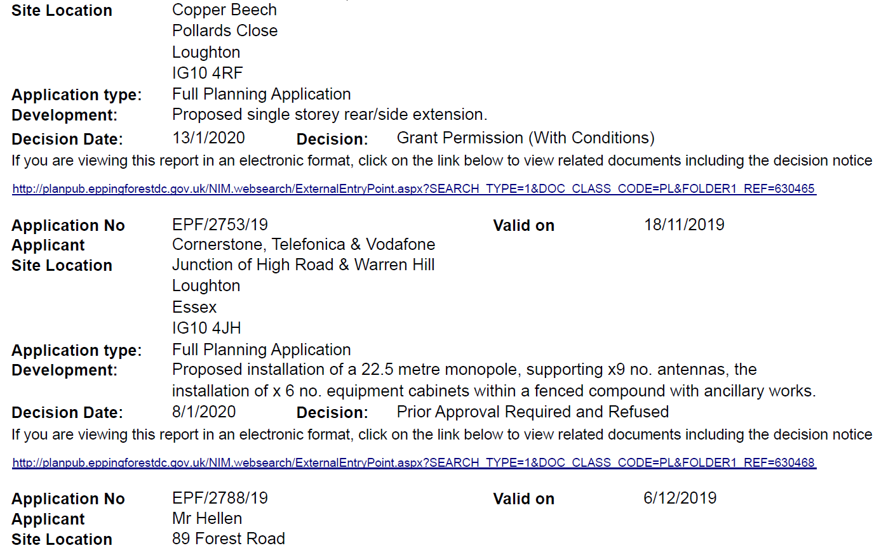

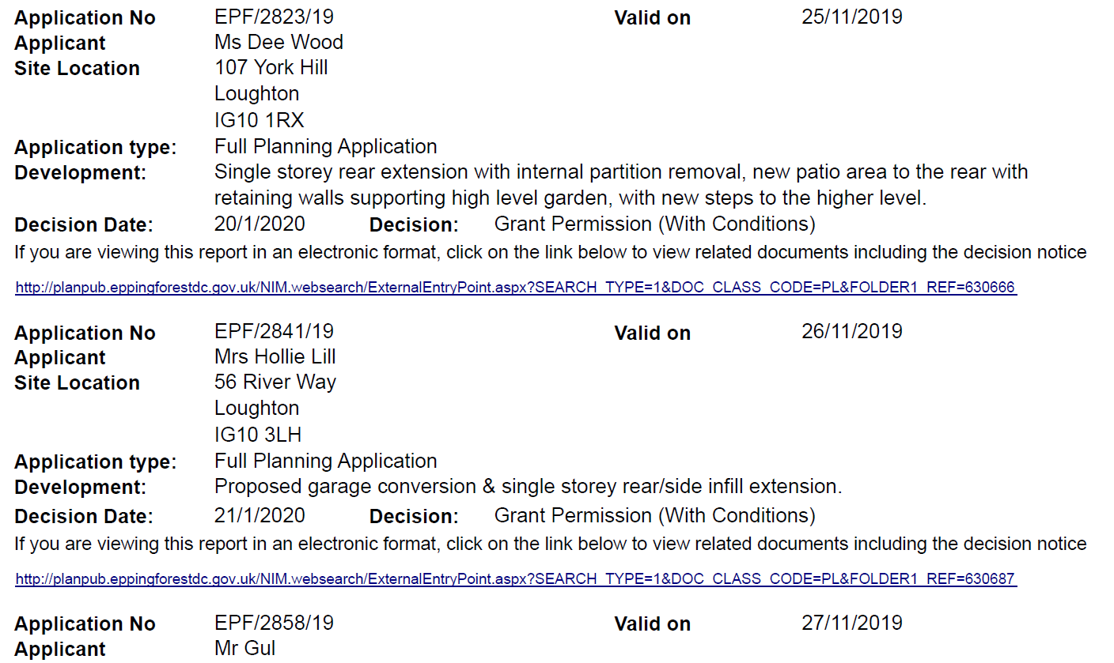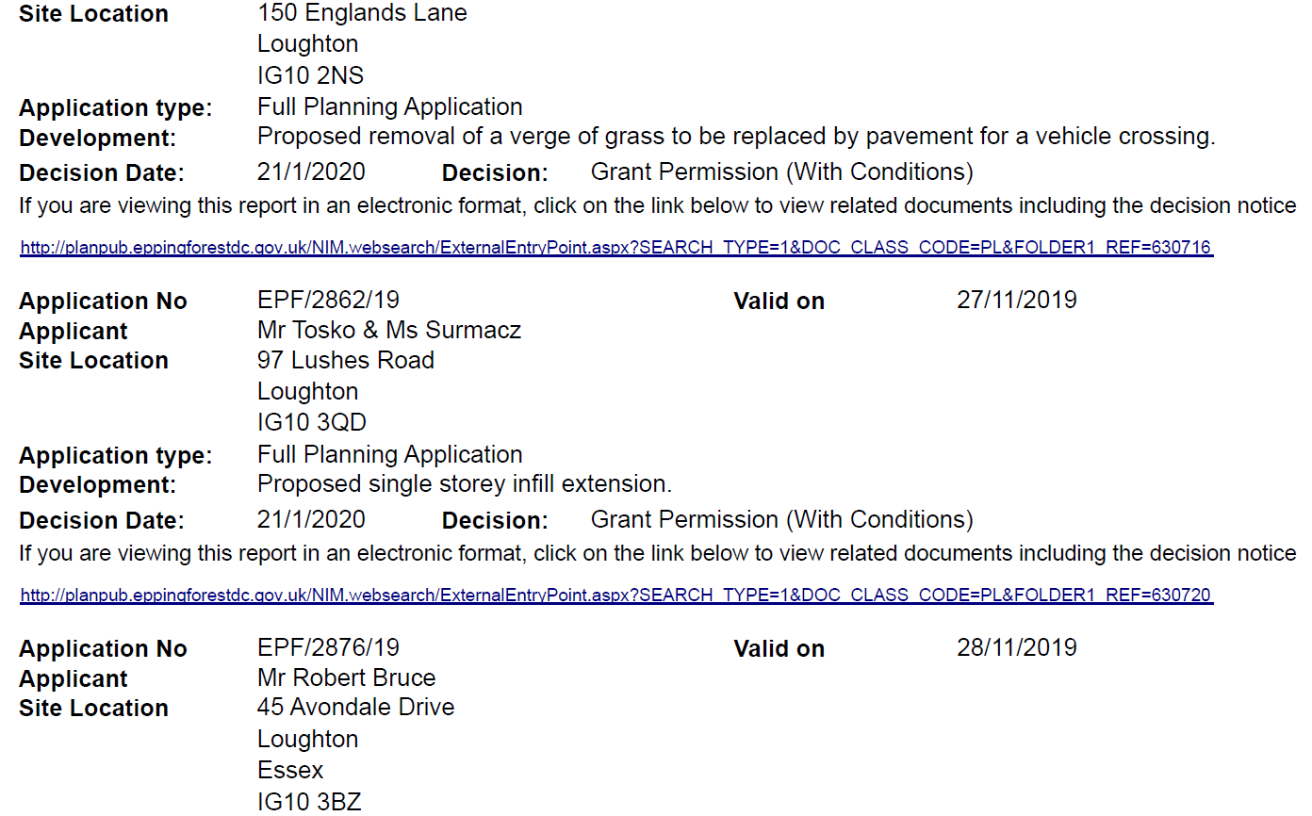

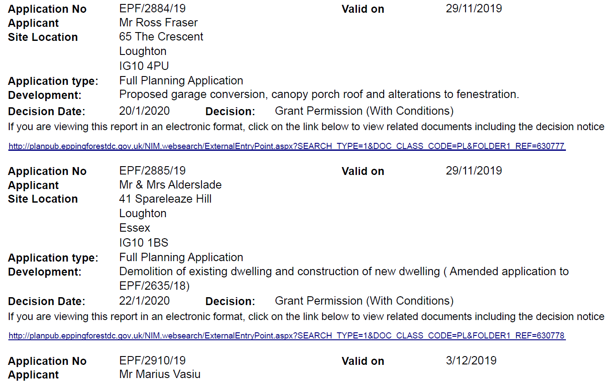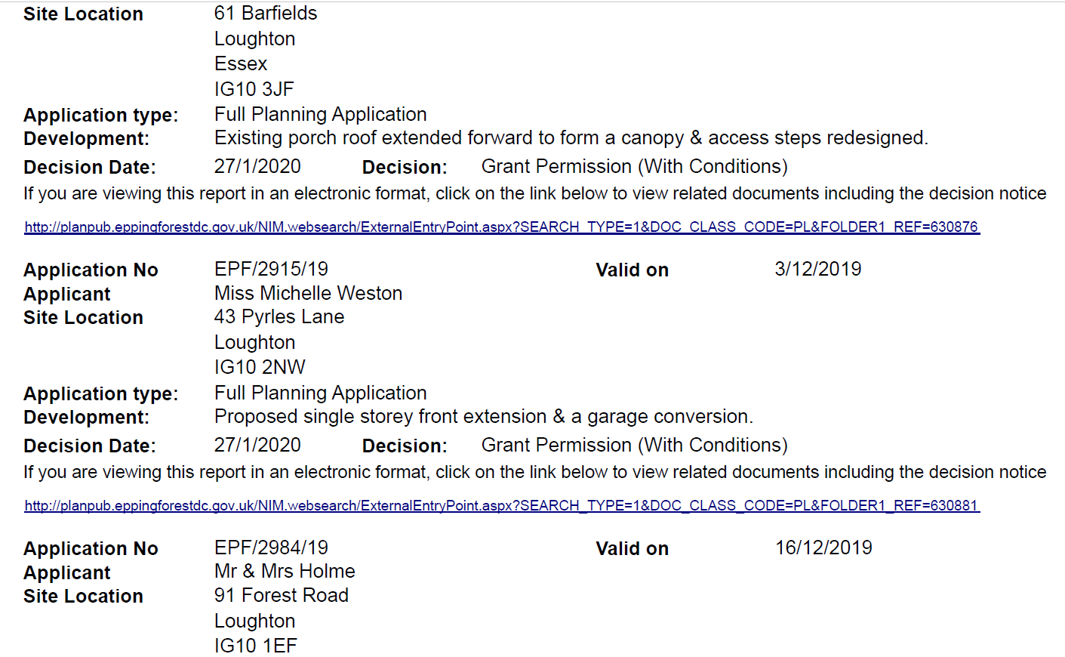

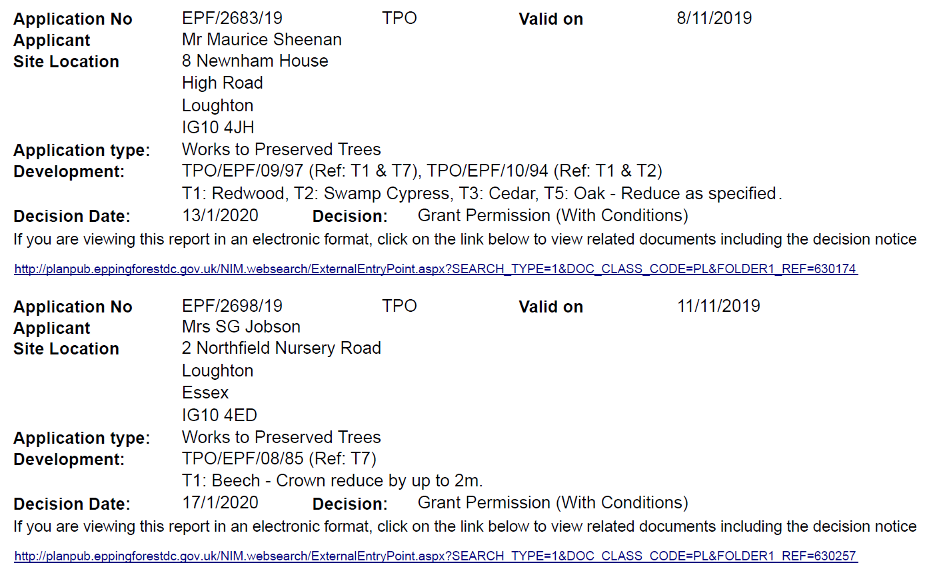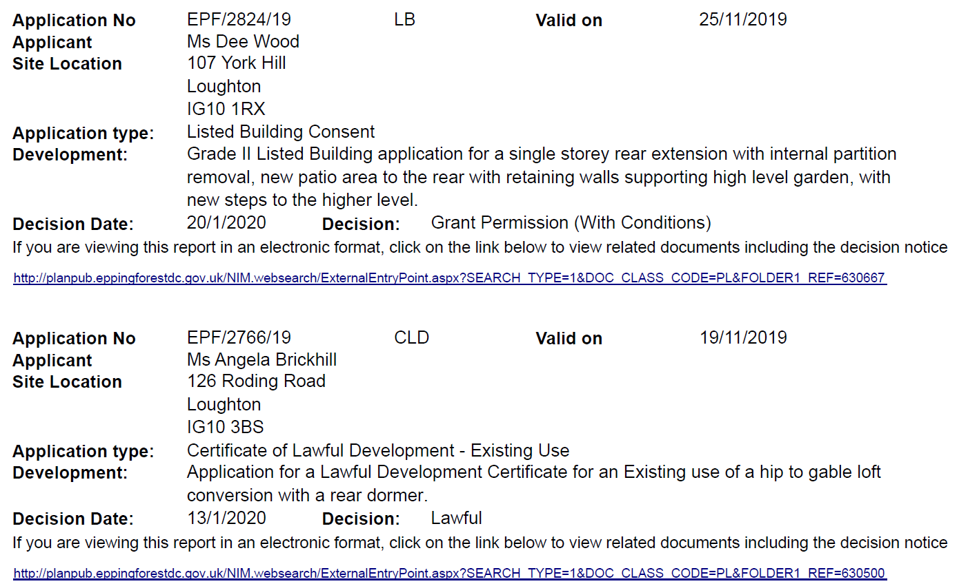

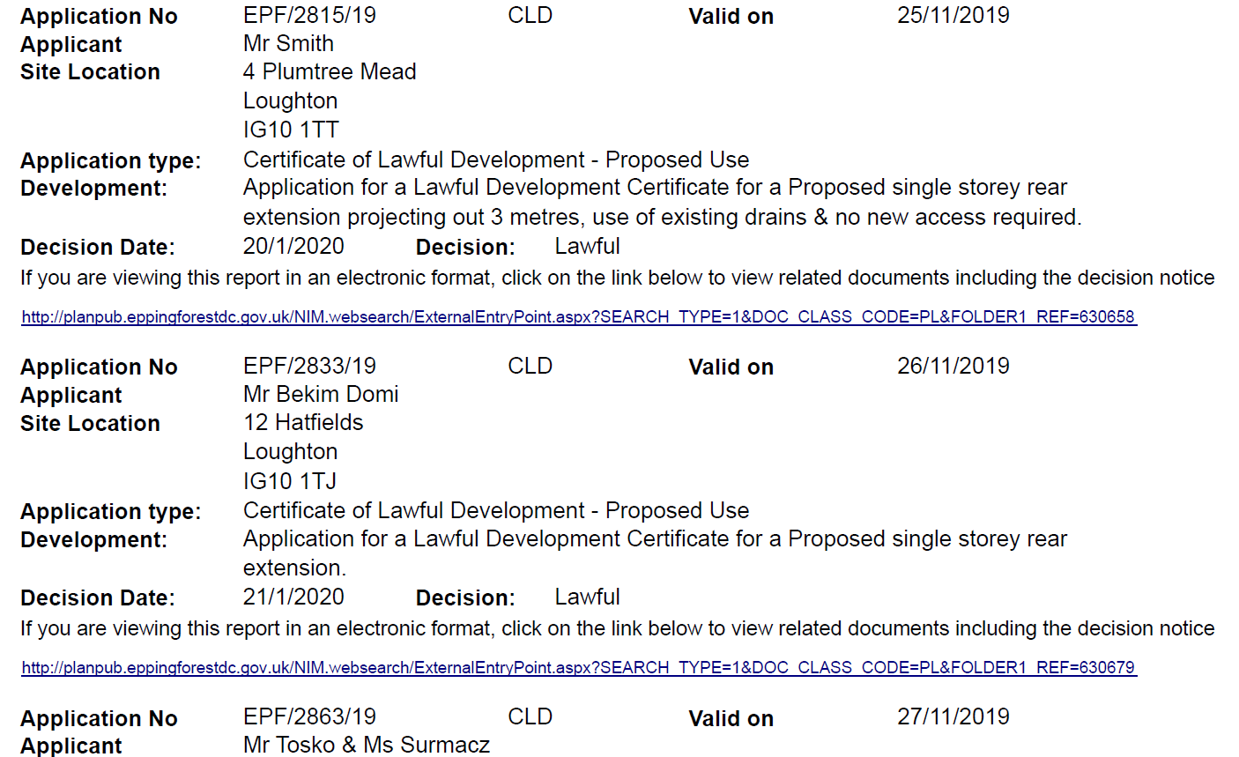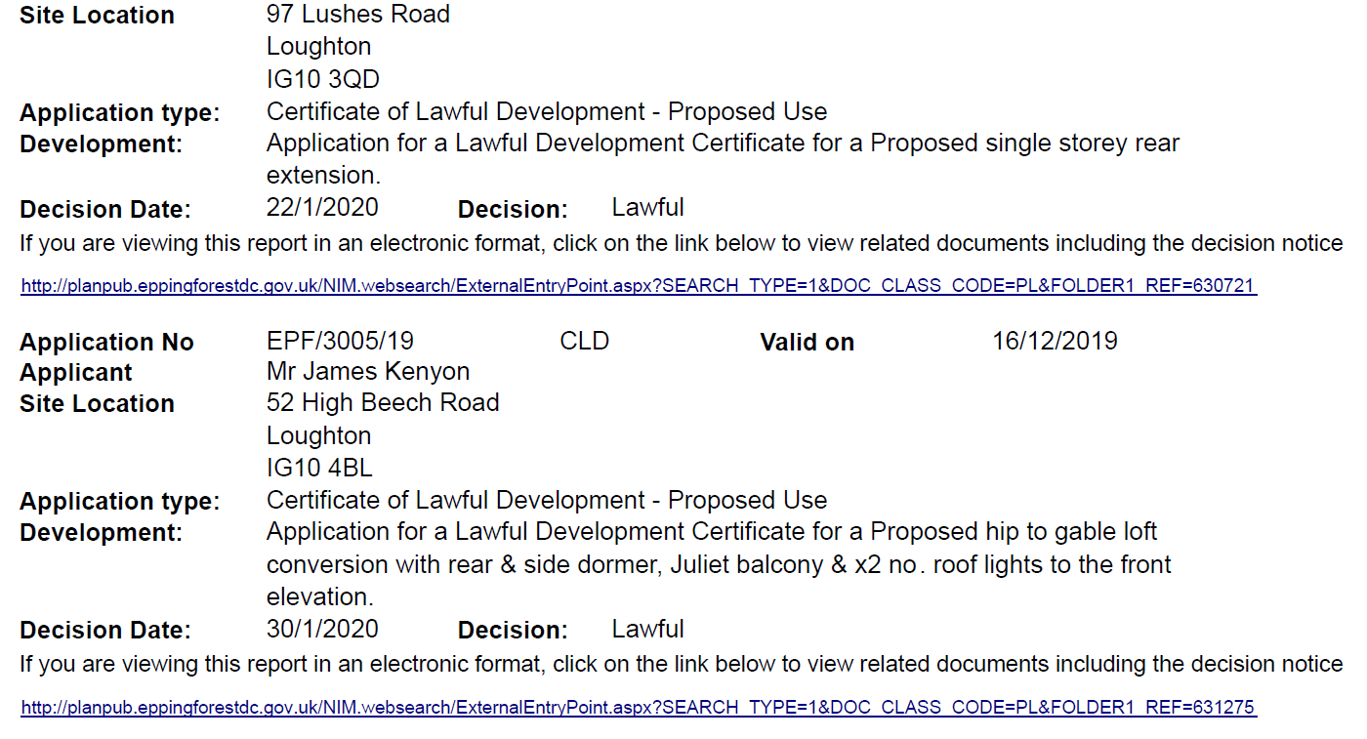

Agenda item 7

Local Government (Miscellaneous Provisions) Act 1982 Street Trading Licence

Street Trading Consent (Renewal) – Debden Broadway Market – Mr Peter Sparks of Debden Traders Association

